EENG 385 - Electronic Devices and Circuits

Audio Board: Power Supply

Lab Handout

# Objective

The objective of this lab is to study the components and design of a power supply including linear regulators, Zener diodes and reverse voltage protections.

# Power Supply Components

The main power input to the Audio board is 9V, supplied by a 110 VAC/ 9V DC wall converter or from the lab power supplies. This 9V level is then converted to 5V or 2.5V for the op amp circuit.

The main 9V power input is sent, unregulated, to the power amplifier driving the speaker. Unregulated means whatever voltage provided to the board is passed directly onto the power amplifier. There are reasons for doing this and the board should be fine up to 30V. Above this and you will be driving some of the components beyond their maximum-rated voltages and run the risk of overheating the power amplifier. Proceed down this path incrementally and with caution.

Now, back to the 5V and 2.5V. These two voltages are supplied to the Audio board using voltage regulators. A voltage regulator is a circuit element supplying a constant voltage to a load independent of the input voltage and of the load’s current requirements. As a practical matter, all voltage regulators have limits to the range of input voltages and load currents.

## LM7805

Before diving into the details of the LM7805, let’s take a minute to talk about how it works. The LM7805 is a linear regulator. The input voltage to the linear regulator is always higher than the voltage supplied to the load. Linear regulators are not power efficient; you will never see one in a cell phone or laptop. This case is because linear regulators dissipate a power equal to the difference between the input and output voltages times the current being supplied to the load. So, for example, if the input voltage to a linear regulator is 9V, the output voltage 5V, and 250 mA of current is being supplied to the load, the linear regulator will dissipate (9V – 5V)*0.25A = 1 Watt of power. Yikes, that is going to make the regulator very hot and unsafe to touch!

In the pantheon of linear regulators, one family stands above the rest, the LM78xx. The “xx” in the family name is a numerical code of the output voltage. We are using the 7805 in our design, so the linear regulator will output 5V.

Let’s learn about the capabilities of this jellybean component by examining its technical documents.

* Open the bill of materials (BOM) for the Audio board found on the Canvas page for the lab.
* Find the row for the 7805. It is a linear voltage regulator. Locate the Digikey part number. Note, all Digikey part numbers end with “-ND”.
* Open the Digitkey.com web site and search for the part number you just found.
* On the resulting part page, open the PDF datasheet.

Use the information on the datasheet to answer the following questions. When referencing a figure in the technical documents, I will use the notation “TD-Figure” as opposed to “Figure” which references to figures in this document.

1. What two things make the LM7805 essentially indestructible?

**The L7805 has internal current limiting and thermal shutdown.**

1. Use TD-Figure 2 to name each of the 3 pins below. For example, A = GND, B = GND, C=GND. Clearly, this is not the correct answer.

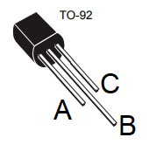

**A = pin 3 = Vin B = pin 2 = GND C = pin 1 = Vout**

1. Look at TD-Table 1, what is the absolute maximum input voltage for our regulator?

**For an output voltage between 3.3V to 9V, the maximum input voltage is 30V.**

1. Look at TD-Table 1, what is the absolute maximum output current for our regulator?

**The 7805 can deliver up to 100 mA output current.**

1. The minimum difference between the input voltage and the output voltage is called the dropout voltage. Find the TD-Table for the electrical characteristics for our linear regulator. What is the dropout voltage?

**Vd is the dropout voltage and equals 2V.**

## Zener Diode Regulator

The 2.5V regulated voltage source (half of the 5V supply) is needed for two op amp inputs. Since this supply does not need to deliver much power, the design uses one of the lowest cost options for a voltage regulator, a Zener diode.

When an increasing, reversed-biased (meaning its cathode potential is higher than its anode) voltage is applied to the Zener diode, it reaches its breakdown voltage, where it starts allowing large amount of electric current to flow. There are an almost unlimited variety of different breakdown voltages to choose from. We are using a Zener diode with a 2.5V breakdown voltage configured as shown in Figure 1.

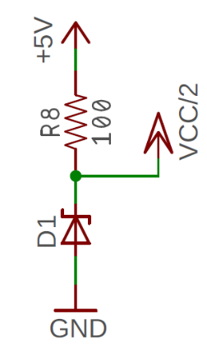

Figure : A voltage regulator made from a Zener diode.

Let’s learn about the capabilities of this jellybean component by examining its technical documents.

* Open the BOM for the Audio board found on the Canvas page for this lab.
* Find the row for the Zener diode and locate its Digikey part number.
* Open the Digitkey.com web site and search for the part number you just found.
* On the resulting part page, open the PDF datasheet.

Use the information on the datasheet to answer the following questions. When referencing a figure in the technical documents, I will use the notation “TD-Figure” as opposed to references to figures in this document which are notated “Figure”.

1. What two markings will you always see on a device package?

**The device is marked with $Y//22//1B. The 22 and 1B are always printed.**

1. The power dissipated in a Zener diode is the breakdown voltage (the voltage drop across it) times the current. What is the power dissipated by the Zener diode on our board (shown in Figure 1)? Represent your answer in milliwatts.

**The power dissipated is 2.5V times the current through the resistor, 2.5V/100 Ω = 0.025 A. Thus 2.5V * 0.025 A = 0.0625 W = 62.5 mW**

1. What is the maximum power potentially dissipated by the Zener Diode?

**The Absolute Maximum Ratings table states the maximum power dissipation is 500 mW.**

## Power-on LED

A power-on LED shown in Figure 2 provides positive confirmation the power is bring delivered to the circuit. This component is a “must-add” to any PCB you are designing and will save you many hours of head-scratching and wondering when diagnosing malfunctions which are the result of no power being supplied to your circuit.

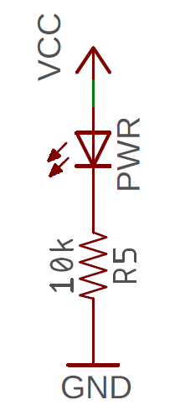

Figure : The power-on LED uses a current limiting resistor to set the LED’s brightness.

When considered as a circuit element, an LED is first and foremost a diode. Thus, the current flows from the anode to the cathode while dropping voltage. The brightness of the light emitted from an LED is proportional to the current flowing through the LED. The wavelength of the light emitted from an LED is roughly inversely proportional to the forward voltage drop. For example, long wavelength colors like red (680 nm) have low voltage drops (1.7V), while shorter wavelength colors like blue (450 nm) have higher voltage drops (3.7V).

The resistor in series with the LED limits the current flowing through the LED. Let’s work through the following questions to understand how to choose the value for this resistor. Start by pulling the technical documents for the LED by using its Digikey part number from the BOM.

1. What is the maximum continuous current possible for sending through the LED?

**The maximum continuous current for this LED is 30 mA.**

1. What is the dominate wavelength of the light emitted by our LED?

**The dominant wavelength is 572 nm.**

1. What is the typical forward voltage drop of the LED when 20 mA is flowing through the LED?

**The forward voltage drop at 20 mA is 2.1V**

1. Assuming VCC = 9V, what is the voltage drop across the current limiting resistor R5 in Figure 2? Use the current from the previous problem to help answer the question.

**The voltage drop across the current limiting resistor is 9V – 2.1V = 6.9V.**

1. Assuming VCC = 9V, how much current flows through the current limiting resistor R5 in Figure 2? This current will be different from the current in the previous problem – I am looking for an estimate of the current, not an exact value.

**The current through the current limiting resistor is 6.9V/10,000 Ω = 0.69 mA**

1. Check the Forward Current vs. Forward Voltage graph in the technical document. Is the voltage drop across the LED at this (low) current close to the voltage drop given in Question 3?

**Yes, the voltage drop at 0.69 mA is close to 2.1V provided in Question 2.**

1. Given the circuit configuration shown in Figure 2, what is the maximum VCC you can supply without exceeding the maximum continuous current through the LED?

**The LED current is equal to (VCC-2.1V)/10 kΩ. At 30 mA, this yields VCC = 297.9V.**

1. Given the circuit configuration shown in Figure 2 with VCC=9V, what is the smallest resistance you can use for R5 without exceeding the maximum continuous current through the LED?

**The LED current is equal to (9-2.1V)/R5. At 30 mA, this yields R5 = 230 Ω.**

1. What resistance of R5 would you choose if you wanted 5 mA to flow through the LED with VCC=9V?

**The LED current is equal to (9-2.1V)/R5. At 5 mA this yields R5 = 1,380Ω.**

## On/Off switch

Few electrical components are simpler than an on/off switch. Yet, if you are not careful, you can make an embarrassing mistake in your silk screen that indicates the wrong direction for on and off. Let’s look at switches so you can avoid such embarrassing mistakes.

Switches are characterized by the number of throws and the number of poles. Throws refers to the number of positions you can place the switch in. Our on/off switch has two positions (left and right), so it is called a double throw. A more sophisticated rotary switch may have as many as 10 positions making it a 10-throw switch. Poles refers to the number of parallel switches moved with the single switch actuator. Our on/off switch actuates one circuit, so it is a single pole. A switch turning on two circuits (like a light and a motor) is called a double pole. Hence, our on/off switch is a single-pole, double-throw (SPDT) switch.

Almost every SPDT slide switch I have ever worked with has a conductive slide to be moved between pairs of terminals like the slide switch shown in Figure 3. Moving the actuator to the left/right connects the center pin to the left/right pin respectively. The center pin is often called the common pin because it is common with either actuator position. Rocker switches have an internal mechanical pivot causing the actuator to connect the pair of pins opposite the actuators position. Again, the center pin of a rocker switch is called the common pin because it is in common with either actuator position.

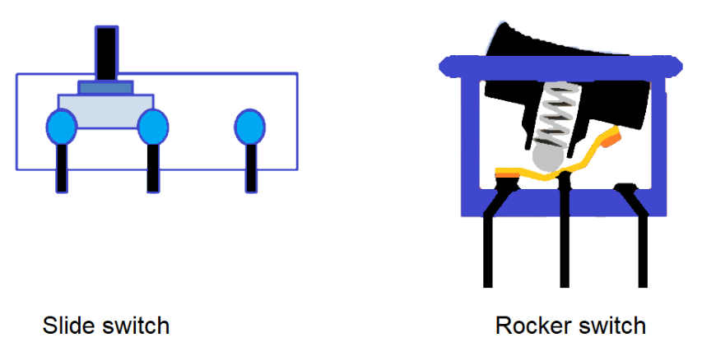

Figure : Two common types of SPDT switches.

Let’s dive into the technical documents to see how these concepts are conveyed in manufacturer’s datasheets. Start by pulling the technical documents for the slide switch used for the Audio board by finding its Digikey part number in the BOMs.

1. Using the BOM for the Audio board, what is the manufacture part number for the slide switch? Use this part number to locate the correct switch in the E-Switch technical document.

**~~The manufacture part number is EG1218.~~**

**The Digikey information page states the switch is rated for a maximum of 24V and 300 mA.**

1. What is the maximum voltage and current that Audio board switch can handle? Use the information posted on the Digikey parts page for this switch. This information is on the product specification page, not in the technical documents

**~~The Digikey information page states the switch is rated for a maximum of 30V and 200 mA.~~**

**The manufactures technical documents do not clearly identify which terminals are connected together for each actuator position.**

Now, let’s move on to the details of assembling your Audio board.

# Reverse Voltage Protection

It is said that to err is human. When working with your audio board, one of the mostly costly errors that you could make would be to apply the 9V and GND power inputs backwards, called reverse voltage. On an unprotected circuit, prolonged application of reverse voltage will permanently damage components like op amps, BJTs and MOSFETs. To prevent this tragedy, your audio board comes equipped with the reverse voltage protection circuit shown in Figure 4.

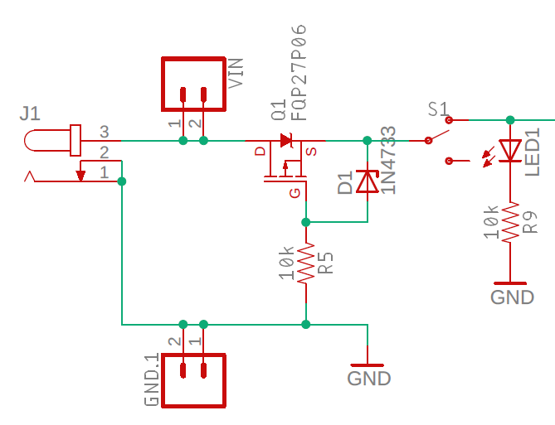

Figure : The reverse voltage protection circuit for the audio board.

The reverse voltage protection circuit consists of three components, the PMOS transistor Q1, resistor R5 and Zener diode D1. In order to understand how this circuit functions, you first need to understand the behavior of the PMOS transistor. The 3-terminals of a MOSFET are called the drain (D), gate (G), and source (S). The left side of Figure 5 shows the schematic view of a MOSFET with these terminals labeled.

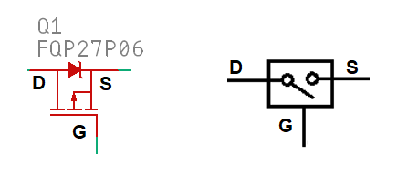

Figure : The schematic of the PMOS transistor used in the reverse voltage protection circuit.

We will use the PMOS transistor as a voltage-controlled switch as shown on the right side of Figure 5. The behavior of this switch is given by the following two statements.

* When the gate voltage is less than the source voltage, the switch is closed. In other words, the drain and source are connected.
* When the gate voltage is greater than the source voltage, the switch is open. In other words, the drain is disconnected from the source.
* The diode between the drain and source terminals of the PMOS transistor is called the body diode and an intrinsic part of the PMOS transistor – not something that you will solder in. When forward biased this diode causes the source to be 0.7V lower than the drain to start the PMOS transistor operating. Once operating, the body diode is ignored.

To understand the functioning of the circuit, it is helpful to eliminate R2 and D1 in Figure 4 and connect the gate of the PMOS transistor is connected directly to GND as shown in Figure 6.

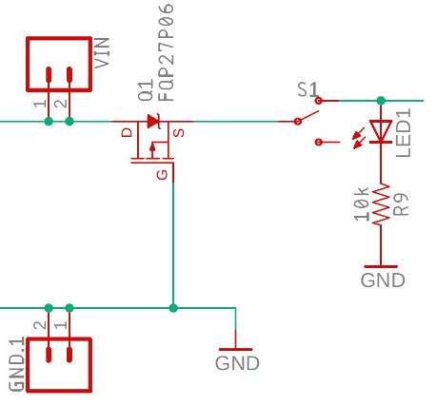

Figure : A simplified version of the reverse voltage protection circuit used on the audio board

Use this simplified schematic and the behavior of the PMOS transistor to answer the following questions.

1. Assume that you hooked up the power correctly, with Vin = 9V and GND = 0V.
   1. Is the body diode forward or reverse biased?

**The body is forward biased because the diode goes from the Drain to the Source.**

* 1. Is the source at a higher or lower voltage than the gate?

**The source is at a higher potential than the gate.**

* 1. Is the PMOS transistor acting like an open or closed switch?

**The PMOS transistor acts like a closed switch.**

1. Assume that you hooked up the power backwards, with Vin = 0V and GND = 9V. Whoops!
   1. Is the body diode forward or reverse biased?

**The body diode is reverse biased so no current flows.**

* 1. Is the source at a higher or lower voltage than the gate?

**The source will be at a lower (or equal) voltage to the gate.**

* 1. Is the PMOS transistor acting like an open or closed switch?

**The PMOS transistor acts like an open switch.**

This is awesome, if you hook up your power cables backwards, the PMOS transistor will act like an open switch and the dangerous reverse voltage will not make it into your circuit. Now we need to understand the role of R2 and D1 that we removed to make the analysis in Figure 6.

Pull the technical documents for the PMOS transistor using its Digikey part number: FQP27P06-ND.

1. What is the maximum Gate-Source voltage in the absolute Maximum Ratings section?

**The maximum gate source voltage is ±25V**

I’ve been teaching classes long enough to know that one of you is going to exceed this voltage in your effort to increase the volume of your audio output. Hence the introduction of R2 and D1. Pull the technical documents Zener using its Digikey part number: 1N4733AFSCT-ND

1. What is the typical Zener voltage, VZ for the 1N4733A?

**The typical Zener voltage for the 1N4733A is 5.1V.**

1. How much current must flow through the 1N4733A in order to maintain this voltage? This is the so-called Zener current and given by IZK.

**The Zener current for the 1N4733A is 1mA.**

If you properly power up the audio board with Vin=10.1V and GND=0V:

1. What voltage will appear between the Gate and Source of the PMOS transistor in Figure 4? Assume the Source = Vin.

**The gate source voltage is 10.1V – 5.1V = 5V.**

1. What current will flow through the Zener diode? Assume the Source = Vin.

**The current through the Zener is given by Ohm’s law: I = 5V/10k = 0.5mA. This is less than the Zener current so the Zener may drop less than 5.1V across its terminals.**

# Assembly

This lab document does not contain any information of the assembly process. Please consult the Assembly Guide posted on Canvas for more information.

# Turn In:

1. Make a record of your response to numbered items below and turn in a single copy as your team’s solution on Canvas using the instructions posted there.
2. Include the names of both team members at the top of your solutions.
3. Use complete English sentences to introduce what each of the items listed below is and how it was derived.

**LM7805**

Questions 1 – 5

**Zener Diode**

Questions 1 – 3

**Power-on LED**

Questions 1 – 9

**ON/OFF switch**

Questions 1 – 2

**Reverse Voltage protection**

Questions 1 – 7

**Assembly**

Solder only the components in the power supply area

Operational and tested

* + Power-on LED
  + 5V
  + 2.5V
  + Show reverse voltage protection works by applying reverse voltage and verify that the current drawn by the power supply is 0mA